**USING DENDROGRAMS**

How to get the maximum values out of HC algorithm>

We look at the horizontal level and set threshold.

(actually distance threshold or dissimilarity threshold )

Then we can say that we do not want dissimilarities to be greater than this level.

In the following example let us set the threshold to be 1.7

Below this line we can say that everything has dissimilarities less than 1.7

By looking at the dendrogram we can also tell how many clusters will be there by seeing that how many vertical lines are crossed by the threshold line.

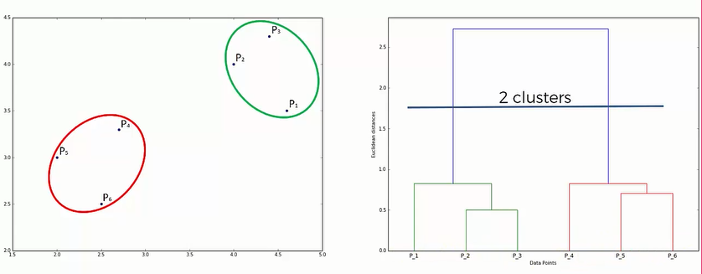

But, how do you find actual optimal number of clusters?

-> Look for the highest vertical distance on the dendrogram such that it is not crossed by any horizontal line.

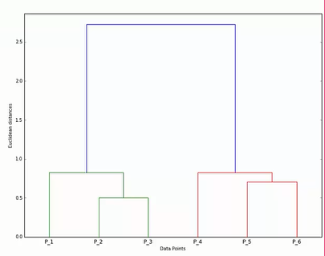For example, in the following graph the three lines shown by arrows cannot be chosen as they are crossed by the hypothetical horizontal line.